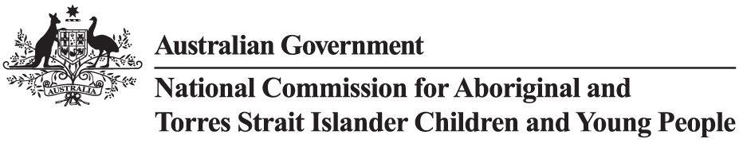

|  |  |  |  |  |  |  |  |  |  |  |  |  |
| --- | --- | --- | --- | --- | --- | --- | --- | --- | --- | --- | --- | --- |
| **Senate Order on Entity Contracts (Senate Order) 1 July 2024 - 30 June 2025** | | | | | |  |  |  |  |  |  |  |
|  |  |  |  |  |  |  |  |  |  |  |  |  |
| **Agency** | **Supplier Name** | **Description** | **Category** | **Agency Ref. ID** | **Confidentiality - Contract (Y/N)** | **Confidentiality Reason(s) -**  **Contract** | **Confidentiality - Outputs (Y/N)** | **Confidentiality Reason(s) - Output** | **Publish Date** | **Start Date** | **End Date** | **Value (AUD) incl. GST** |
| National Commissioner for Aboriginal and Torres Strait Islander Children and Young People | The Trustee of We Al-li Trust | Staff Training | Education and Training Services |  | N |  | N |  | 29-Aug-25 | 27-Jun-24 | 04-Jul-25 | $15,400.00 |