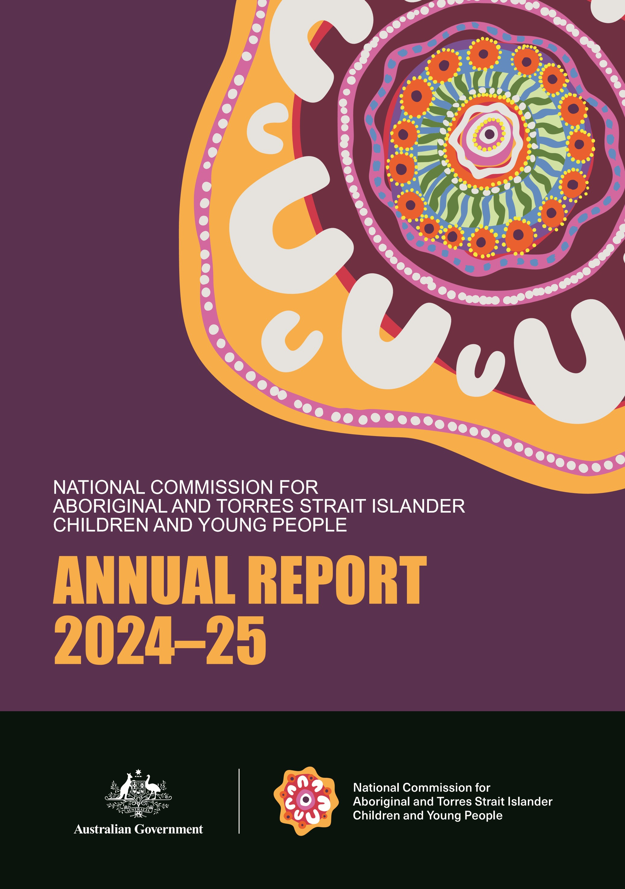
A

International Standard Serial Numbers
ISSN 3083-4457 (online)
ISSN 3083-4449 (print)

Copyright notice

This document is licensed under the Creative Commons Attribution 4.0 International Licence
Licence URL: https://creativecommons.org/licenses/by/4.0/legalcode
Please attribute: © Commonwealth of Australia (National Commission for Aboriginal and Torres Strait Islander Children and Young People) 2025

Notice:
- If you create a derivative of this document, the National Commission for Aboriginal and Torres Strait Islander Children and Young People requests the following notice be placed on your derivative: Based on Commonwealth of Australia (National Commission for Aboriginal and Torres Strait Islander Children and Young People) information.
- Enquiries regarding this licence or any other use of this document are welcome. Please contact the National Commission for Aboriginal and Torres Strait Islander Children and Young People at enquiries@ncatsicyp.gov.au

Notice identifying other material or rights in this publication:
- Australian Commonwealth Coat of Arms – not Licensed under Creative Commons. See
https://www.pmc.gov.au/honours-and-symbols/commonwealth-coat-arms

Acknowledgement of Country
The National Commission for Aboriginal and Torres Strait Islander Children and Young People (the National Commission) acknowledges the Traditional Custodians of Country throughout Australia and recognises their continued care of and connection to land, water, culture and community. The National Commission pays respect to Aboriginal and Torres Strait Islander cultures, and to Elders both past and present.

Acknowledgement of lived and living experience
The National Commission acknowledges and thanks all children and young people with lived and living experience who have shared their stories, insights, and wisdom over many years.
The National Commission honours the strength, resilience, and leadership of Aboriginal and Torres Strait Islander children and young people, and commits to listening deeply, walking alongside, and amplifying their voices in all aspects of the National Commission’s work.
The National Commission recognises the definition of children as those aged 0–12 and young people as those aged 12–24, in line with the Australian Institute of Health and Welfare.

Note on language
The terms Aboriginal and Torres Strait Islander, First Nations, and Indigenous are used respectfully and interchangeably throughout this document when referring to First Nations peoples of Australia. These terms are used to respectfully encompass the diversity of cultures, identities, and preferences of Aboriginal and Torres Strait Islander people.

Contact details
The website of the National Commission is at www.ncatsicyp.gov.au.
For further information, contact Dr Moira Byrne by sending an email to the National Commission’s enquiries mailbox at enquiries@ncatsicyp.gov.au.

Letter of transmittal

Dear Minister
I am pleased to present the annual report of the National Commission for Aboriginal and Torres Strait Islander Children and Young People for the financial year 2024-25.
This report has been prepared for the purposes of section 46 of the Public Governance, Performance and Accountability Act 2013 (PGPA Act), which requires that an annual report be given to the entity’s responsible Minister for presentation to the Parliament.
This report includes the entities audited annual financial statements as required by subsection 43(4) of the PGPA Act. It also includes the entities annual performance statements as required under section 39 of the PGPA Act.
In accordance with section 10 of the PGPA Act, and as required by subsection 17AG(2) of the Public Governance, Performance and Accountability Rule 2014, I certify that:
- the Department of Social Services (the Department) prepared fraud and corruption risk assessments and fraud and corruption control plans
- the Department had appropriate mechanisms to prevent, detect, investigate, record and confidentially report suspected fraud and corruption
- I took all reasonable measures to appropriately deal with fraud relating to the Department.
Yours sincerely

Sue-Anne Hunter
National Commissioner for Aboriginal and Torres Strait Islander
Children and Young People
31 October 2025

Table of contents

Acknowledgement of Country 0
Acknowledgement of lived and living experience 2
Note on language 2
Contact details 2
Letter of transmittal 3
Table of contents 4
Review by the National Commissioner 7
Overview of the National Commission for Aboriginal and Torres Strait Islander Children and Young People 8
Our purpose 8
Our story 8
Our structure 9
Our work 9
Accountable authority 10
Report on the performance of the entity 11
Annual performance statements 11
Overview 11
Statements of preparation 12
Results 13
Activity 1: Amplifying the voices, aspirations and strengths of Aboriginal and Torres Strait Islander children and young people 14
Activity 2: Providing advice to Government 17
Activity 3: Enhancing national coordination on matters related to Aboriginal and Torres Strait Islander children and young people 20

Report on financial performance 22
Financial Statements 23
Independent Auditor’s Report 23
Statement by the Commissioner and the Chief Financial Officer 26
Annual financial statements 28
Notes to and forming part of the financial statements 31
Management and accountability 40
Corporate governance 40
Fraud and corruption control 40
Significant non-compliance with finance law 41
Audit and Risk Committee 41
Audit and Risk Committee members and qualifications 42
External scrutiny 43
Privacy 43
Management of human resources 44
Managing and developing employees 44
Workplace agreements 45
Employee statistics 45
APS employee statistics 46
Performance pay 47
Executive remuneration 47
Assets management 48
Purchasing 48
Contract expenditure 48
Reportable Consultancy and Non-Consultancy Contracts 48
Strategic Commissioning Framework 49
Exempt contracts 49
Small business 49

Other mandatory information 50
Advertising and market research 50
Grants 50
Disability reporting 50
Freedom of information 51
Remediation of information published in previous annual reports 51
Appendices 52
Appendix 1: Other legislative requirements 52
Environment Protection and Biodiversity Conservation Act 1999 52
Climate Action in Government Operations 53
Work Health and Safety Act 2011 55
Carer Recognition Act 2010 55
Appendix 2: Aids to Access 56
Abbreviations and acronyms 56
Appendix 3: List of requirements 57
Index 64

Review by the National Commissioner
There’s a word in my language that means to come with purpose: Wominjeka.
As the first National Commissioner for Aboriginal and Torres Strait Islander Children and Young People, I honour the efforts of my acting predecessor, Lil Gordon who ‘came with purpose’ to establish the Commission.
In its establishment phase, the National Commission for Aboriginal and Torres Strait Islander Children and Young People (the National Commission) met with crucial stakeholders, including:
- Aboriginal community-controlled organisations
- state and territory Commissioners, Guardians and Advocates
- the peak body for Commissioners, Guardians and Advocates, including our counterparts from Aotearoa (New Zealand).
We leveraged our collective voice through joint statements to help raise the profile of issues that are important to us all.
This is our first Annual Report and these are accomplishments we can note with pride. They would not have been achieved without the dedicated staff in the National Commission, supported by staff in the Department.
The National Commission will continue to work with our national and jurisdictional counterparts, government, Aboriginal-controlled community organisations, researchers and most importantly, children and young people. As we do, I look forward to hearing and amplifying the voices of children and young people, particularly those with lived experience of out-of-home care and incarceration. Their perspectives are critical to informing our advice to government and making change. Our Corporate Plan for 2025–26 outlines the key activities we will undertake over the next reporting period.
I am honoured to lead the National Commission going forward. I want every child and young person to feel respected and valued. Our children and young people are the beating heart of our communities and a brilliant kaleidoscope of possibilities for the future.
I hope all who are interested in the work of the National Commission ‘come with purpose’ to join us in making a difference for our next generations.

Overview of the National Commission for Aboriginal and Torres Strait Islander Children and Young People

Our purpose
The purpose and role of the National Commission for Aboriginal and Torres Strait Islander Children and Young People (the National Commission) is to protect and promote the rights, interests, and wellbeing of Aboriginal and Torres Strait Islander children and young people by amplifying their voices, aspirations, and strengths; embedding their perspectives and priorities in advice to government; and collaborating with key stakeholders to enhance collective impact and drive systemic reform.

Our story
The National Commission is a non-corporate Commonwealth entity based in the Social Services portfolio. The National Commission was established on 13 January 2025 through an Executive Order (published in the Commonwealth Government Gazette on 26 September 2024, and available at legislation.gov.au with the reference number C2024G00584).
The National Commissioner reports directly to the Minister for Social Services, the Hon Tanya Plibersek MP.
The establishment of the National Commission under the executive order is an important first step in the realisation of an ongoing, fully legislated and empowered National Commission.
Subject to the passage of primary legislation that articulates the National Commission’s mandate, powers, functions, and responsibilities, the second phase of establishment will deliver the independence and authority needed to drive systemic, transformational, and sustainable change.
The National Commission is working with government, key stakeholders and the Department to inform and support the development of primary legislation.

Our structure
The structure of the National Commission as at 30 June 2025 is detailed in the following diagram.
Social Services Portfolio

Our work
As documented in the Portfolio Budget Statement for the Social Services portfolio, the National Commission is responsible for the outcome:
Amplifying the voices of Aboriginal and Torres Strait Islander children and young people, by providing strategic, independent and impartial advice about policy, reforms and services, and promoting and enhancing coordination on matters related to Aboriginal and Torres Strait Islander children and young people.
During this period, the National Commission liaised with stakeholders across the country to develop this outcome. The Corporate Plan 2025–26 outlines the National Commission’s forward program of work. It is available on the website at www.ncatsicyp.gov.au/resource/2025-26-corporate-plan.

Accountable authority
The accountable authority of the National Commission for the reporting period was Acting National Commissioner Lil Gordon, from the commencement of operations (13 January 2025) to the end of the reporting period (30 June 2025).
The ongoing National Commissioner, Sue-Anne Hunter, is the accountable authority at the time of the Annual Report’s finalisation, submission to the Minister, publication, and tabling to Parliament. Commissioner Hunter commenced in the role on 1 September 2025.

National Commissioner
Sue-Anne Hunter

Report on the performance of the entity

Annual performance statements

Overview
The Annual Performance Statements for 2025 assess the National Commission’s performance against the performance measures set out in the Department’s Portfolio Budget Statement and the National Commission’s 2024–25 Corporate Plan.
As stated in the Social Services Portfolio Budget Statement, the National Commission has a single planned outcome:
National Commissioner for Aboriginal and Torres Strait Islander Children and Young People. The Government will establish an interim National Commissioner, as a first step towards establishing an ongoing, legislated and independent National Commissioner. It will also establish an Office of the National Commissioner which, when established, will act to protect and promote the rights, interests and wellbeing of Aboriginal and Torres Strait Islander children and young people. This measure also aligns with the Early Years Strategy.
Performance measures are largely qualitative to capture engagement, where practical. This is buttressed by select quantitative numbers, for example, the number of interactions and engagements.
In the National Commission’s first year of operation, the performance measures also include the establishment of core operations, team capability, and the strategic foundations of key activities.
As the National Commission collaborates with children, young people, and key stakeholders on emerging initiatives, performance measures will evolve to reflect the outcomes that are expected, based on research.

Performance summary
In 2024–25, the National Commission focused on 3 key activities. These 3 activities had 6 performance targets. Of these 6 performance targets, 3 were achieved and 2 were achieved in part.
Modest resourcing and staffing limited the National Commission’s capacity to achieve all 6 performance targets within the five and a half months of the National Commission’s operation to 30 June 2025.
During this period, the National Commission also faced ongoing uncertainty caused by limitations on what Cabinet was able to progress surrounding the federal election and caretaker period. This delayed the appointment of the ongoing National Commissioner and resulted in incremental extensions to the Acting National Commissioner’s tenure, which limited the capacity for forward planning and making commitments that may have affected the ongoing National Commissioner.
A key focus for the National Commission not represented in its performance measures is planning for primary legislation. The National Commission has completed significant work in this area, including consultation with jurisdictional counterparts to determine how its role, powers, and functions can best complement their roles and enhance national coordination; and working with the Department and other key stakeholders to inform and support the development of primary legislation.

Statement of preparation
As the accountable authority of the National Commission, I present the 2024–25 Annual Performance Statements, as required under paragraph 39(1)(a) of the Public Governance, Performance and Accountability Act 2013 (PGPA Act).
In my opinion, the annual performance statements:
- accurately present the entity’s performance in the reporting period, and
- comply with subsection 39(2) of the PGPA Act.

Sue-Anne Hunter
National Commissioner for
Aboriginal and Torres Strait Islander Children and Young People
31 October 2025

Results
The National Commission’s key activities are outlined in the 2024–25 Corporate Plan. These activities are in three areas:
            - Amplifying the voices, aspirations and strengths of Aboriginal and Torres Strait Islander children and young people
            - Providing advice to Government
            - Enhancing national coordination on matters related to Aboriginal and Torres Strait Islander children and young people.
Indicators of success were partially achieved under activities 1 and 2 and achieved in full under activity 3.




Activity 1: Amplifying the voices, aspirations and strengths of Aboriginal and Torres Strait Islander children and young people

The National Commission will engage with Aboriginal and Torres Strait Islander children and young people to ensure that their voices shape decisions that affect them – including the decisions that the National Commission makes. To this end, the National Commission is developing a national youth engagement model to support safe, meaningful, ongoing participation. The National Commission has also established a channel for sending enquiries and complaints, helping align its work with the priorities of children, young people and their families.
Performance Measure

Engagement and collaboration activities to progress the establishment of a youth engagement model that accommodates a diversity of voices
Indicators of Success | 2025 result | Outcome
1.1 Agreements are in place for engaging with existing youth advisory groups both nationally and across jurisdictions. | Achieved in part | The National Commission:  - made informal agreements on collaborative youth engagement approaches with the jurisdictional counterparts consulted to date to leverage existing forums.  - met with First Nations Youth Network to discuss engagement.
1.2 Child safe framework policies are established. | Achieved in part | The National Commission completed draft framework policies.
1.3 Enquiries mechanism is established. | Achieved | The National Commission:  - established an enquiries mechanism, protocols, and standard operating procedures  - managed 19 enquiries.

Analysis of Performance
Agreements with youth advisory groups were partially achieved. The National Commission reached informal agreement with several jurisdictions to collaborate on youth engagement approaches. This included a meeting with the First Nations Youth Network (6 March 2025) and liaison with state and territory bodies to leverage existing forums. While formal agreements are not yet in place, foundational relationships have been established and have informed advice to government on relevant considerations for the development of primary legislation.

Jurisdiction | Participants:  Organisation (number of people) | Number of Organisations | Number of People
SA  Workshop:  Meeting with ACCOs 1:  Meetings with ACCOs 2: | CACYP (3)  CCYP (2)  GCYP (1)  Wakwakurna Kanyini (6)  South Australian Aboriginal Community Controlled Organisations Network (6) | 5 | 18
VIC  Workshop 1:  Workshop 2: | CCYP (9)  Koorie Youth Council (2)  Victorian Aboriginal Legal Service (1)  Victorian Aboriginal Child and Community Agency (1)  Victorian Aboriginal Children and Young People's Alliance (1)  Aboriginal Justice Caucus (1)  Djirra (1)  Bubup Wilam Aboriginal Child and Family Centre (1) | 8 | 17
 | TOTAL | 13 | 35

The establishment of child safe framework policies was partially achieved. Throughout the reporting period, the National Commission engaged with its counterparts in states and territories to discuss the best approaches to engaging with children and young people, as well as reaching marginalised voices in those jurisdictions. This allowed us to build on baseline compliance with the National Principles for Child Safe Organisations to develop a draft framework that is culturally safe and shaped by expertise throughout the country.
As the National Commission completes initial meetings with jurisdictional counterparts, these policies will continue to evolve to reflect best practice considerations in line with the diversity of Aboriginal and Torres Strait Islander children and young people in Australia. These policies support the National Commission’s broader work to protect and promote the rights, interests and wellbeing of children and young people.
The establishment of an enquiries mechanism was achieved. During the reporting period, the National Commission established an enquiries mechanism, protocols, and standard operating procedures. It managed 19 enquiries during the reporting period, demonstrating operational capability and responsiveness. This mechanism supports the National Commission’s role in listening to concerns raised by or on behalf of children and young people.
Overall, the Commission has made principled and robust progress in establishing mechanisms that support youth engagement and child safety. While two indicators are still in development, the activities undertaken reflect a deliberate and inclusive approach to creating strong foundations for meaningful and responsible engagement.



Activity 2: Providing advice to Government

The National Commission is intended to play a key role in advising government on matters that affect Aboriginal and Torres Strait Islander children and young people. This includes informing the development of policy and legislation that supports their rights, interests and wellbeing. The National Commission provides this advice through direct avenues – such as making submissions and reporting, appearing at inquiries, or meeting with elected representatives – and more broadly, through work to align and mobilise stakeholders, target efforts and build momentum, respond to emerging opportunities, exert influence, shape national conversations, and help chart a course for systemic change.
The National Commission has progressed the establishment of frameworks that will allow us to will work with children, young people, their communities, and other key stakeholders to inform advice and how it is provided. This includes supporting children and young people to drive the narrative on issues that affect them. Their guidance will help the National Commission, key stakeholders, and governments understand the issues and their root causes, the context and environmental influences, how well current approaches align with evidence, what values and assumptions underpin the stories told about young people, and what needs to change.
Performance Measure

Extent to which the National Commission engages with Government
Indicators of Success | 2025 result | Outcome
2.1 Database of engagements and policy themes is established. | Achieved in part | Created records of engagement and policy themes and catalogued the summaries of engagements in corporate platforms.

Analysis of Performance
The database of engagements and policy themes was partially achieved in 2025.
In 2024–25, the National Commission’s advice to government primarily focused on that provided to the Department on the development of legislation to define the National Commission’s powers, responsibilities and independence. To inform this advice, the National Commission consulted children’s commissioners, guardians and advocates, as well as community-controlled organisations across jurisdictions.
The National Commission provided other direct advice to Government by appearing at the Senate Inquiry into Australia’s youth justice and incarceration system and endorsing the submission made by the NSW Advocate for Children and Young People to the Review of the operation of doli incapax in NSW for children under 14 (doli incapax refers to whether a child is deemed incapable of forming the intent to commit a crime or tort, especially by reason of age). These engagements contributed to the National Commission’s internal development of policy themes and positions.
The National Commission also engages in international human rights processes in line with its purpose to protect and promote the rights of Aboriginal and Torres Strait Islander children and young people and provide advice to government. During the reporting period, this included engagement with the Universal Periodic Review process and the Committee on the Rights of the Child.
The National Commission provided advice to Government identifying opportunities for leveraging existing commitments to align Government and stakeholder priorities and highlighted the Government’s commitment to a legislated, independent and empowered National Commission as a significant human rights achievement. The National Commission also informed international guidance on children’s right to access to justice and to an effective remedy. This type of engagement ensures that authoritative international guidance on the implementation of treaties considers the unique needs of Aboriginal and Torres Strait Islander children and young people, as well as contributing to the National Commission’s internal development of policy themes and positions.
During the reporting period, the National Commission also contributed to public conversations and messaging to government through media interviews, statements and social media posts.

This includes joint statements with Australian and New Zealand Children’s Commissioners, Guardians and Advocates (ANZCCGA) to enhance collaboration and strengthen the collective impact of their recommendations to government.
The National Commission also began developing policy positions on urgent issues facing Aboriginal and Torres Strait Islander children and young people. These will be discussed with jurisdictional counterparts to ensure that the National Commission’s recommendations are informed by the diversity of circumstances across states and territories, as well as the priorities that other commissioners have developed based on their engagement with First Nations children and young people.
Public commentary is available on the National Commission’s website at www.ncatsicyp.gov.au/news.


Activity 3: Enhancing national coordination on matters related to Aboriginal and Torres Strait Islander children and young people.

One of the National Commission’s functions is to support national coordination on issues affecting Aboriginal and Torres Strait Islander children and young people. This includes working with commissioners, guardians, and advocates across jurisdictions to share knowledge, align policy efforts, and promote consistent approaches to children’s rights and wellbeing. During the reporting period, the National Commission established relationships and contributed to joint initiatives that support collaboration across states and territories.
Performance Measure

Extent to which the National Commission has engaged and collaborated on activities that support sharing of policy, knowledge, and practice across jurisdictions

Indicators of Success | 2025 result | Outcome
3.1 The National Commissioner has met with national and state and territory commissioners, guardians, and advocates. | Achieved | Two in-person workshop meetings with children’s commissioners, guardians and advocates in jurisdictions:  - 12 June 2025 with South Australian representatives  - 20 June 2025 with Victorian representatives  Two meetings with the ANZCCGA on 14–16 May 2025 and with the ANZCCGA First Nations Caucus on 24-26 June 2025.
3.2 The National Commission has published joint statements across jurisdictions. | Achieved | The National Commissioner published three joint statements with the ANZCCGA on the 23 January, 4 March and 24 June 2025. These are published on the NCATSICYP website.
Analysis of Performance
The National Commission achieved its intended engagement and collaboration outcomes despite several operational constraints. The National Commission supported national coordination, met with counterparts across jurisdictions and contributed to joint public statements, achieving both indicators of success for this activity.
The interim nature of the appointment of an Acting National Commissioner meant that the Acting National Commissioner took a measured approach to strategic decisions – particularly staffing – to avoid pre-empting the preferences of the incoming National Commissioner.
Resourcing has required careful prioritisation and the modest establishment funding shaped the scope and sequencing of initiatives. Nonetheless, the National Commission has delivered key outputs and built foundational relationships across jurisdictions.
The National Commission has advanced quickly in establishing core governance structures, reflecting strong stakeholder engagement and a shared commitment to improving outcomes for Aboriginal and Torres Strait Islander children and young people.

This page is intentionally blank.

Report on financial performance

Financial Statements
for the period 13 January 2025 to 30 June 2025



prefaced by the

Independent Auditor’s Report
Australian National Audit Office

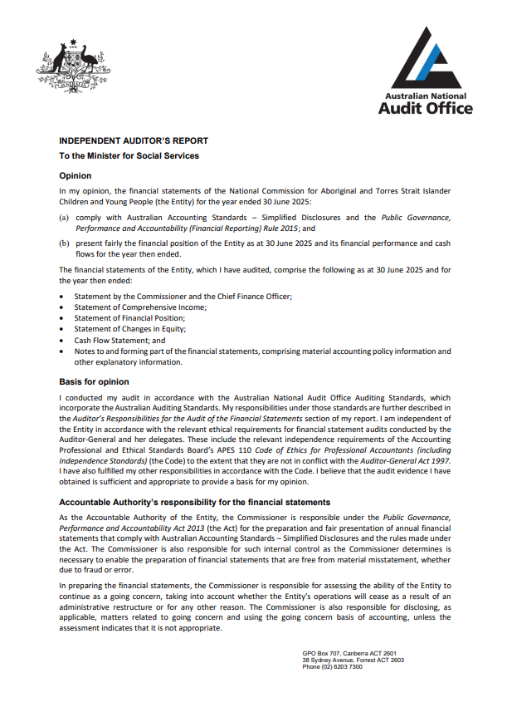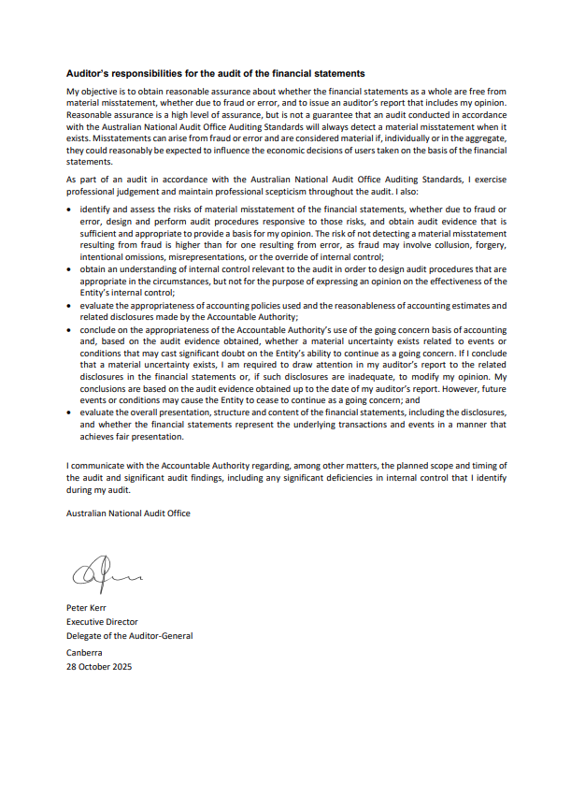

This page is intentionally blank.

Statement by the Commissioner and the Chief Financial Officer

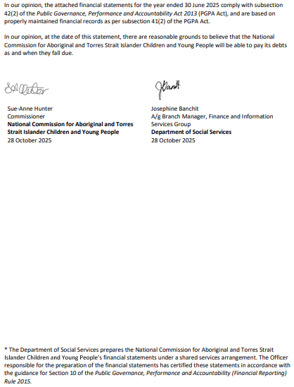

Annual financial statements

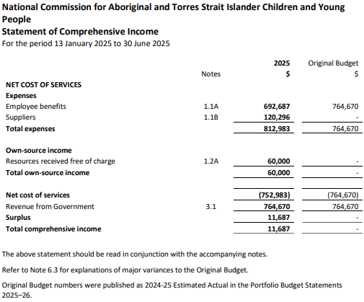
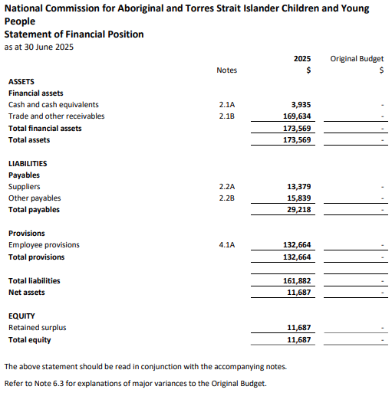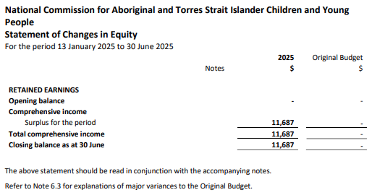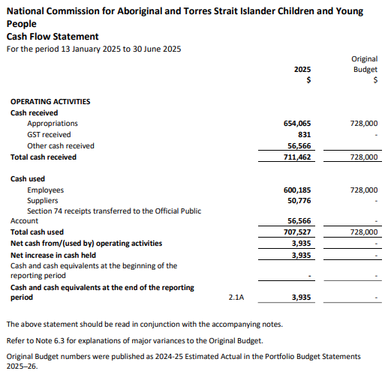

Notes to and forming part of the financial statements

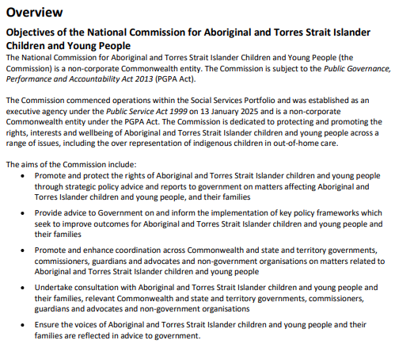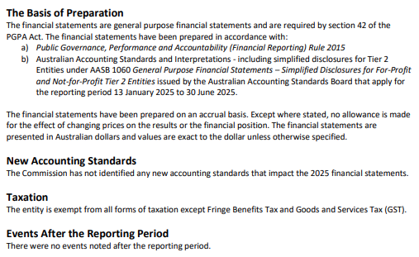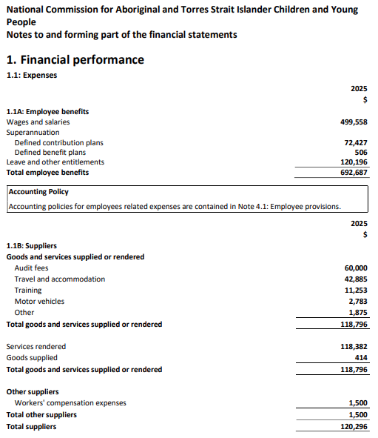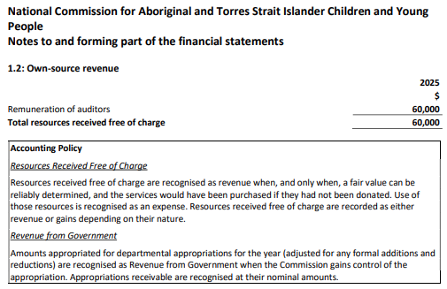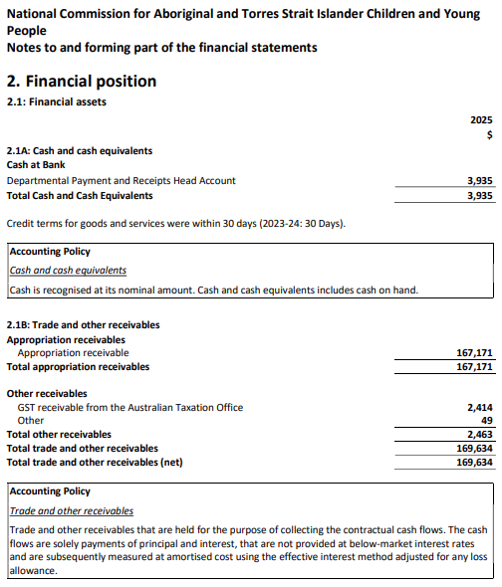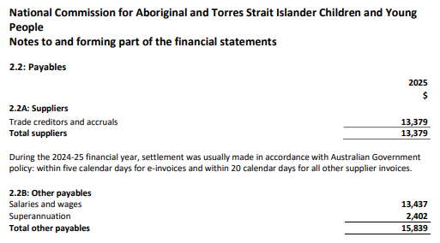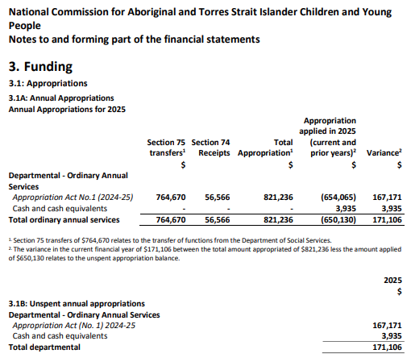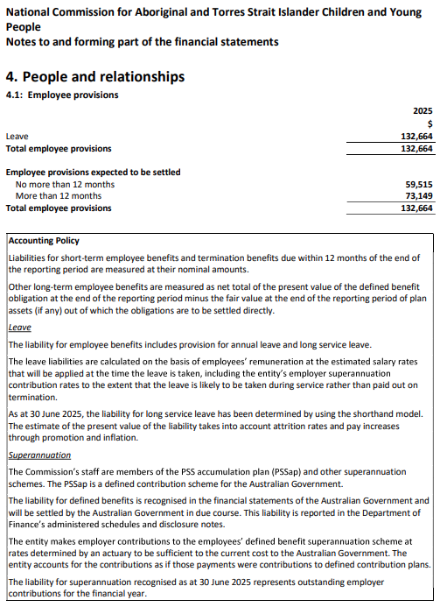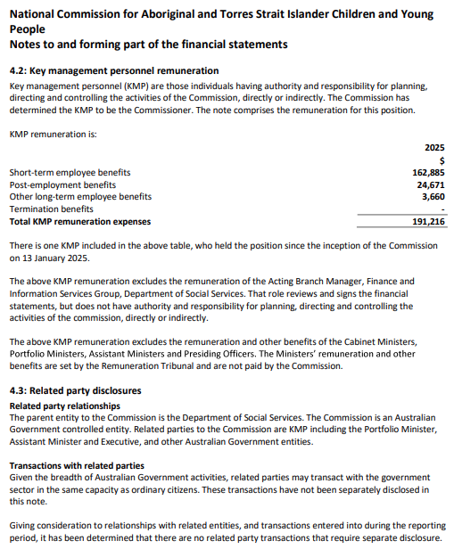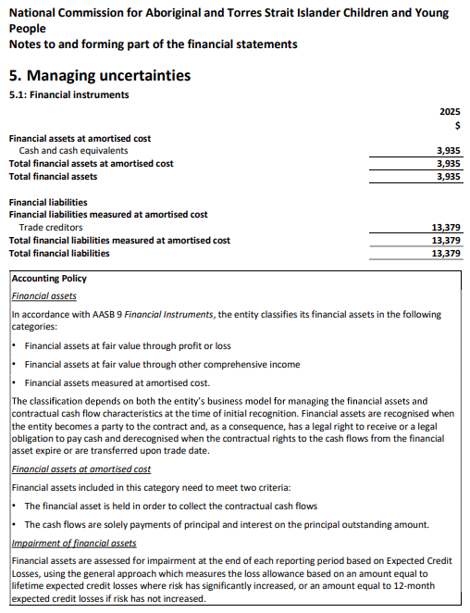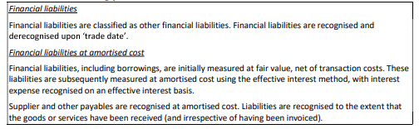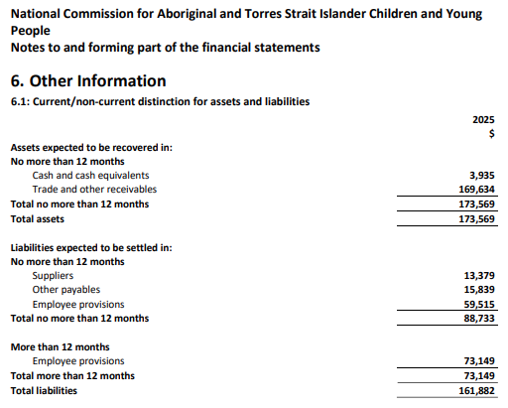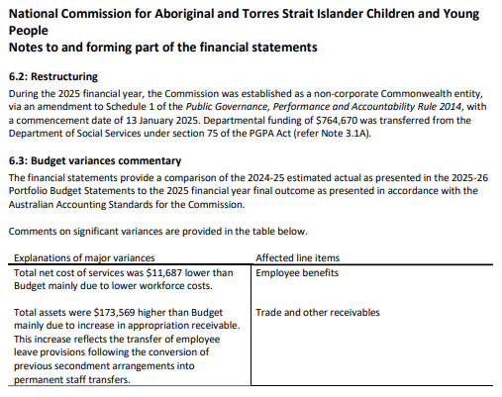

Management and accountability

Corporate governance
The National Commission operates under the Public Governance, Performance and Accountability Act 2013 (Cth) (PGPA Act). The focus throughout the 2024–25 financial year was to continue to establish the Commission’s governance and corporate functions to fulfill all PGPA Act requirements and build organisational capability and capacity to achieve objectives.
As the National Commission is a small agency, it is party to a Memorandum of Understanding (MoU) with the Department. This means the Department delivers corporate services and systems to the National Commission. Such services include office accommodation, people support, financial administration, information technology, security and information management.
The MoU will be reviewed annually and requires close working relationships between the National Commission and the Department.

Fraud and corruption control
Under section 10 of the Public Governance, Performance and Accountability Rule 2014 (Cth) (the Fraud Rule), the National Commission is required to have in place mechanisms to prevent, detect and deal with fraud and corruption.
The National Commission is committed to preventing fraud and corruption against the National Commission and its operations. Fraud and corruption risk is managed through various strategies, including support from the Department under the MoU. The MoU also provides that will manage internal (staff) or external fraud investigations on behalf of the National Commission.
These strategies include:
- educating employees on risk management
- identifying and mitigating fraud, compliance, security and privacy risks
- ensuring that employees are aware of their fraud control responsibilities through regular mandatory online training
- ensuring that fraud and corruption reporting is transparent and accountable.
The National Commission has not reported any instances of suspected fraud or corruption in 2025.
Any reports of suspected fraud or corruption are managed by the Department in line with paragraph (d) of section 10 of the PGPA Rule. This allows officials, clients and members of the public to confidentially report incidents of suspected fraud or corruption and for those incidents to be investigated consistent with the Australian Government Investigations Standards. Departmental investigators have, at least, the minimum qualifications stipulated in the standards.

Significant non-compliance with finance law
There were no significant issues reported to the Minister under paragraph 19(1)(e) of the PGPA Act, which includes compliance with Finance law.

Audit and Risk Committee
The Audit and Risk Committee provides independent assurance and advice to the National Commission on financial and performance responsibilities, risk oversight and management, and the system of internal control.
The Committee consists of an independent Chair and 3 external experts. It meets 6 times per year.

Audit and Risk Committee members and qualifications

Member name | Qualifications, knowledge, skills or experience | Meetings | TAR*
Mr Nick Baker (Chair) | Bachelor of Arts in Computing Studies. Graduate Diploma in Professional Accounting. Certificate IV in Commonwealth Fraud Investigations. Fellow of CPA Australia. Member Australian Computer Society.  Extensive experience in public sector management consulting, experience in financial accounting, performance improvement and IT. | 1 of 1 meeting attended of meetings held | $909
Mr Ian McPhee | Bachelor of Business. Bachelor of Arts. Financial management and budget experience, Department of Finance.  Fellow and Life Member of CPA Australia and fellow of the Institute of Public Administration Australia. Financial statement and performance audit experience with Australian National Audit Office. | 1 of 1 meeting attended of meetings held | $735
Ms Cath Ingram | Bachelor of Arts in Accounting. Certificate IV in Commonwealth Fraud Investigations. Fellow of the Chartered Accountants Australia and New Zealand and the Institute of Public Administration Australia.  Registered Company Auditor for over 20 years and experienced internal auditor and risk management practitioner. Public and private sector experience in governance, risk and assurance. | 1 of 1 meeting attended of meetings held | $735
Mr Darren Box | Bachelor of Business (Accounting). Fellow of CPA. Public sector experience as a Chief Operating Officer with Australian Federal Police (AFP), and Chief Financial Officer with the AFP and Services Australia. | 1 of 1 meeting attended of meetings held | $727
*total annual remuneration excluding GST
The audit committee charter is available on the Department’s website at https://www.dss.gov.au/doing-business-us/resource/audit-and-risk-committee.

External scrutiny
The National Commission and its activities were subject to the following external scrutiny during the reporting period.
- There were no judicial decisions or decisions of administrative tribunals during the year that had, or may have, a significant impact on the National Commission’s operations.
- There were no reports on the National Commission during the reporting period by the Commonwealth Ombudsman or the Office of the Australian Information Commissioner.
- The Delegate for the Auditor-General issued an unqualified report for the 2024–25 financial statements of the National Commission.
- There were no decisions by the Australian Privacy Commissioner that involved the National Commission or that had, or might have, a significant impact on the National Commission’s operations.

Privacy
The Department’s knowledge of the National Commission’s privacy related activities is limited to matters where the Department has advised the National Commission under the Memorandum of Understanding. To the extent of that advice for 2024–2025:
- The Department did not advise the National Commission on any incidents. No eligible data breaches were reported to the Office of the Australian Information Commissioner on behalf of the National Commission.
- The Department completed one Privacy Impact Assessment (PIA) on behalf of the National Commission. The PIA was on the establishment of the National Commission.
- There were no reports on the National Commission during the reporting period by the Commonwealth Ombudsman or the Office of the Australian Information Commissioner.
- There were no decisions by the Australian Privacy Commissioner that involved the National Commission or that had, or might have, a significant impact on the National Commissions’ operations.
Individuals can make a complaint, free of charge, to the National Commission or the Office of the Australian Information Commissioner, if they believe their personal information has been mishandled.

Management of human resources

Managing and developing employees
The National Commission has worked to create a workforce that will support its establishment and develop a plan to achieve its strategic objectives. The National Commission continues to build its workforce and develop capability to support the National Commissioner.
Employees possess a diversity of skills, knowledge and experience across multiple disciplines including stakeholder engagement, communications, policy, governance and service delivery. The National Commission is committed to fostering a culturally safe workplace and centring the interests of Aboriginal and Torres Strait Islander children and young people in everything the National Commission does.
The National Commission used department-seconded staff and temporary acting arrangements, as well as services provided by the Department under the MoU.
The National Commission’s health, safety and wellbeing, information and technology capability, staff training and support, property and building services, corporate services, and human resources support are provided under a shared services arrangement with the Department.
As part of Department’s mandatory training, staff are required to complete 13 courses covering such things as APS values and behaviour, financial principles, privacy awareness, records, management, work health and safety and including core cultural learning about Aboriginal and Torres Strait Islander Australia.
In the establishment phase, the National Commission operates under the Department’s Enterprise Agreement 2024–2027. National Commission staff are afforded the same conditions as those of the Department and are guided by the same human resources policies.

Workplace agreements

Public Service Act 1999 Employment arrangements 2025
 | SES | Non-SES | Total
Enterprise Agreement | - | - | -
Australian Workplace Agreement | - | - | -
Common Law Contracts | - | - | -
Determination under subsection 24(1) of the Public Service Act 1999 | - | 2 | 2
Total | - | 2 | -
Secondees from the Department are not listed in this table as they are reported in the Department’s Annual Report.

Non-salary benefits for employees
The National Commission’s workforce is employed under the Department’s enterprise agreement. The Department’s enterprise agreement offers a range of non-salary benefits for staff. These include, but are not limited to, leave, flexible working arrangements, salary packaging through Smartsalary, and remote working assistance.

Employee statistics

All Ongoing Employees with the National Commission
As at 30 June, the National Commission had two ongoing employees: the Executive Assistant to the National Commissioner and the Director – Strategy and Rights.
Demographic information on the employees is not included due to the small number of staff. This respects the privacy of individual members of staff who may be able to be identified.
Staff working in the National Commission as at 30 June were located in the Australian Capital Territory, Victoria and New South Wales, and there was a mix of genders.

APS employee statistics

Public Service Act 1999 Ongoing Employees
As at 30 June, the National Commission had three ongoing employees: the Acting National Commissioner, the Executive Assistant and the Director – Strategy and Rights.
As at 30 June, the Department was resourcing the National Commission with six of its own ongoing employees: the Acting Director – Operations and Government Relations, the Acting Assistant Director – Compliance and Reporting, the Acting Director – Collaborate and Amplify, the Assistant Director – Engagement, the Acting Assistant Director – Strategic Policy, and the Co-ordinator – Enquiries, Media and Advice. Employment statistics for these employees are included in the Department’s Annual Report.
Demographic information on the employees is not included due to the small number of staff. This respects the privacy of individual members of staff who may be able to be identified. There are a diversity of backgrounds and identities.
Staff working in the National Commission as at 30 June were located in the Australian Capital Territory, Victoria and New South Wales, and there was more than 50% First Nations representation across the National Commission. All staff were full-time.

Public Service Act 1999 Employment Salary Ranges by Classification Level (Minimum/Maximum)
 | Minimum Salary ($) | Maximum Salary ($)
EL 2 | $144,495 | $170,360
EL 1 | $122.594 | $139,157
APS 6 | $98,393 | $110,595
APS 5 | $89,831 | $95,932
Minimum/Maximum range | $89,831-$144,495 | $95,932-170,360

Performance pay
The National Commission did not have arrangements for performance pay during the reporting period – that is, its period of operation from 13 January to 30 June 2025.

Executive remuneration

Information about remuneration for key management personnel

Name |  | Lil Gordon
Position Title |  | Acting National Commissioner
Short term benefits | Base salary | 162,599
Short term benefits | Bonuses | -
Short term benefits | Other benefits and allowances | 286
Post employment benefits | Superannuation contributions | 24,671
Long-term benefits | Long service leave | 3,660
Long-term benefits | Other long-term benefits | 0
Termination benefits |  | -
Total remuneration |  | 191,216

Information about remuneration for senior executives
There were no other senior executives at the National Commission for Aboriginal and Torres Strait Islander Children and Young People.

Information about remuneration for other highly paid staff
There were no other highly paid staff at the National Commission for Aboriginal and Torres Strait Islander Children and Young People.

Assets management
Management of the assets of the National Commission for Aboriginal and Torres Strait Islander Children and Young People is governed by its Memorandum of Understanding with the Department. These align with accounting standards and government best practice. The Department maintains an asset register, asset management policies and a capital management plan.

Purchasing
The National Commission’s purchasing activities are supported under the shared service MoU with the Department. All procurement policies are set out in departmental policies, which are in line with the Commonwealth Procurement Rules 2020. Purchasing is made in an accountable and transparent manner, complying with Australian Government policies and meeting relevant international obligations.
In 2024–25, the Department procured services from a First Nations business on behalf of the National Commission. This will be reported in the Department’s annual report.
The National Commission will work towards exceeding targets under the National Indigenous Australians Agency’s Indigenous Procurement Policy.

Contract expenditure
Annual reports contain information about actual expenditure on reportable non-consultancy contracts. Information on the value of reportable non-consultancy contracts is available on the AusTender website.

Reportable Consultancy and Non-Consultancy Contracts
During the 2024–25 reporting period, no new reportable consultancy or non-consultancy contracts were entered into, so there are no main categories of purposes for which consultants were selected and engaged to report. Therefore, there were also no Australian National Audit Office access clauses.
Any consultancies entered into by the National Commission would use the Department’s policies and procedures for selecting and engaging consultants.

Strategic Commissioning Framework
The National Commission is committed to the Strategic Commissioning Framework. The National Commission is identifying its core work and looking to deliver it in-house in the first instance. It is recruiting and developing APS employees and considers outsourcing core work in limited circumstances ensuring benefits for the APS. Going forward, it will seek to embed an approach to set and deliver on targets to bring core work in-house.

Exempt contracts
During the 2024–25 reporting period, no new exempt contracts were entered into. Therefore, there were no Australian National Audit Office access clauses.

Small business
The National Commission supports small business participation in the Commonwealth Government procurement market. Small and Medium Enterprises (SME) and Small Enterprise participation statistics are available on the Department of Finance's website.
The National Commission will support small and medium sized enterprises through its procurement practices. As of 30 June 2025, no procurements were entered into by the National Commission.
The National Commission recognises the importance of ensuring that small businesses are paid on time. The results of the Survey of Australian Government Payments to Small Business are available on the Treasury’s website.

Other mandatory information

Advertising and market research
The National Commission did not conduct any advertising campaigns during the period.

Grants
There were no grants awarded by the National Commission during the 2024–25 reporting period.

Disability reporting
Australia’s Disability Strategy 2021–2031 (the Strategy) is the overarching framework for inclusive policies, programs and infrastructure that will support people with disability to participate in all areas of Australian life. The Strategy sets out where practical changes will be made to improve the lives of people with disability in Australia. It acts to ensure the principles underpinning the United Nations Convention on the Rights of Persons with Disabilities are incorporated into Australia’s policies and programs that affect people with disability, their families and carers. All levels of government have committed to deliver more comprehensive and visible reporting under the Strategy. A range of reports on progress of the Strategy’s actions and outcome areas will be published and available at https://www.disabilitygateway.gov.au/ads.
Disability reporting is included the Australian Public Service Commission’s State of the Service reports and the APS Statistical Bulletin. These reports are available at http://www.apsc.gov.au.

Freedom of information
The National Commission is an agency subject to the Freedom of Information Act 1982 (Cth) and is required to comply with the Information Publication Scheme (IPS) requirements.
The National Commission will finalise its IPS agency plan in 2025–26. During 2024–25, the National Commission did not receive a request under the FOI Act.
The National Commission’s Freedom of Information and Information Publication Scheme infrastructure is within the Department. The website for Freedom of Information and the Information Publication Scheme is at www.dss.gov.au/access-information.
Further information Freedom of Information requests to the Department is at www.dss.gov.au/access-information/freedom-information.
The Freedom of Information disclosure log for the Department is at www.dss.gov.au/access-information/freedom-information/our-freedom-information-disclosure-log.

Remediation of information published in previous annual reports
This report is the National Commission’s first annual report.

Appendices

Appendix 1: Other legislative requirements

Environment Protection and Biodiversity Conservation Act 1999
Section 516A of the Environment Protection and Biodiversity Conservation Act 1999 (Cth) requires Commonwealth agencies to report against two core criteria:
- how the activities of the agency accord with and contribute to the principles of ecologically sustainable development
- the environmental performance of the agency, including the impact of its activities on the natural environment, how these impacts are mitigated and how they will be further mitigated.
The National Commission does not administer any legislation, so does not administer legislation with a direct impact on ecologically sustainable development. The principles relating to scientific certainty and biological diversity are of limited application to the National Commission’s activities.
The National Commission’s operations fall into five categories of environmental impact: electricity consumption, water use, waste generation, paper use and transportation. The National Commission has low staffing numbers and are located within the Department tenancies in Canberra, Wagga Wagga and Melbourne.
The National Commission supports measures taken by the Department to minimise the effect of activities on the environment. Such measures include
- reducing electricity through use of heating and cooling air conditioning timers in meeting rooms and breakout areas and efficient lighting solutions
- promoting correct waste management behaviours
- reducing paper file holdings and physical storage requirements through the Department’s digitisation program.
Quantitative information on measures taken by the Department to minimise the effect of activities on the environment and environmental performance data on energy and waste production is available in the Department’s
2024-25 Annual Report.

Climate Action in Government Operations
The National Commission is reporting emissions for the first time in 2024–25 and is only reporting for part of the financial year. Not all data sources were available at the time of the report and amendments to data may be required in future reports. Emissions from hire cars for 2024-25 may be incomplete due to a lack of robust data. The quality of data is expected to improve over time as emissions reporting matures.
A portion of the National Commission property-related activity data was unable to be separated from the Department’s data. This has been included in the Department’s annual report.

Emissions Inventory Tables (required for Annual Reports)
2024-25 GREENHOUSE GAS EMISSIONS INVENTORY–
LOCATION-BASED METHOD
Emission Source | Scope 1 t CO₂-e | Scope 2  t CO₂-e | Scope 3 t CO₂-e | Total  t CO₂-e
Electricity (Location Based Approach) | N/A | - | - | -
Natural Gas | - | N/A | - | -
Solid Waste | - | N/A | - | -
Refrigerants | - | N/A | N/A | -
Fleet and Other Vehicles | - | N/A | - | -
Domestic Commercial Flights | N/A | N/A | 6.89 | 6.89
Domestic Hire Car | N/A | N/A | 0.02 | 0.02
Domestic Travel Accommodation | N/A | N/A | 2.31 | 2.31
Other Energy | - | N/A | - | -
Total t CO₂-e | - | - | 9.22 | 9.22
Note: the table above presents emissions related to electricity usage using the location-based accounting method. CO₂-e = Carbon Dioxide Equivalent.
n/a = not applicable

2024-25 ELECTRICITY GREENHOUSE GAS EMISSIONS
Emission Source | Scope 2 t CO₂-e | Scope 3 t CO₂-e | Total t CO₂-e | Electricity kWh
Electricity (Location Based Approach) | - | - | - | -
Market-based electricity emissions | - | - | - | -
Total renewable electricity consumed | n/a | n/a | n/a | -
Renewable Power Percentage¹ | n/a | n/a | n/a | -
Jurisdictional Renewable Power Percentage^{2, 3} | n/a | n/a | n/a | -
GreenPower² | n/a | n/a | n/a | -
Large-scale generation certificates ² | n/a | n/a | n/a | -
Behind the meter solar⁴ | n/a | n/a | n/a | -
Total renewable electricity produced | n/a | n/a | n/a | -
Large-scale generation certificates ² | n/a | n/a | n/a | -
Behind the meter solar⁴ | n/a | n/a | n/a | -
Note: The table above presents emissions related to electricity usage using both the location-based and the market-based accounting methods. CO₂-e = Carbon Dioxide Equivalent. Electricity usage is measured in kilowatt hours (kWh).
¹ Listed as Mandatory renewables in 2023-24 Annual Reports. The renewable power percentage (RPP) accounts for the portion of electricity used, from the grid, that falls within the Renewable Energy Target (RET).
² Listed as Voluntary renewables in 2023-24 Annual Reports.
³ The Australian Capital Territory is currently the only state with a jurisdictional renewable power percentage (JRPP).
⁴ Reporting behind the meter solar consumption and production is optional. The quality of data is expected to improve over time as emissions reporting matures.

Work Health and Safety Act 2011
The National Commission acknowledges and is committed to fulfilling its responsibilities under the Work Health and Safety Act 2011, the Work Health and Safety Regulations 2011, and the Safety, Rehabilitation and Compensation Act 1988.
As already mentioned, as part of Department’s mandatory training, staff are required to complete a module on work health and safety.
The National Commission uses the work health and safety policies and processes of the Department as part of the MoU. Information on initiates, health and safety outcomes, statistics of notifiable incidents, any investigations and other matters is in the Department’s 2024-25 Annual Report.

Carer Recognition Act 2010
The National Commission complies with its responsibilities to carers in line with the obligations of all public service agencies under the Carer Recognition Act 2010 (Cth).

Appendix 2: Aids to Access
Aids to access required by the PGPA Rule and prepared in line with the PGPA Rule are included in this Annual Report so that readers can navigate the annual report easily, and locate information efficiently. The List of Requirements is set out on the following pages.
The website for the National Commission is at www.ncatsicyp.gov.au. The Annual Report is at the page www.ncatsicyp.gov.au/about-us-integrity-maintaining-our-standards/corporate-reporting.

Abbreviations and acronyms

Abbreviation or acronym | Description
ACCO | Aboriginal community-controlled organisation
ANZCCGA | Australian and New Zealand Children’s Commissioners, Guardians and Advocates
APS | Australian Public Service
Department, the | Department of Social Services
FOI Act | Freedom of Information Act 1982 (Cth)
IPS | Information publication scheme
MoU | Memorandum of Understanding
National Commission, the | National Commission for Aboriginal and Torres Strait Islander Children and Young People
National Commissioner, the | National Commissioner for Aboriginal and Torres Strait Islander Children and Young People
PGPA Act | Public Governance, Performance and Accountability Act 2013 (Cth)
PGPA Rule | Public Governance, Performance and Accountability Rule 2014 (Cth)

Appendix 3: List of requirements

PGPA Rule Reference | Part of Report | Description | Requirement
17AD(g) | Letter of transmittal
17AI | Page 3 | A copy of the letter of transmittal signed and dated by accountable authority on date final text approved, with statement that the report has been prepared in accordance with section 46 of the Act and any enabling legislation that specifies additional requirements in relation to the annual report. | Mandatory
17AD(h) | Aids to access
17AJ(a) | Page 4 | Table of contents (print only). | Mandatory
17AJ(b) | Page 64 | Alphabetical index (print only). | Mandatory
17AJ(c) | Page 56 | Glossary of abbreviations and acronyms. | Mandatory
17AJ(d) | Page 57 | List of requirements. | Mandatory
17AJ(e) | Page 2 | Details of contact officer. | Mandatory
17AJ(f) | Page 2 | Entity’s website address. | Mandatory
17AJ(g) | Page 56 | Electronic address of report. | Mandatory
17AD(a) | Review by accountable authority
17AD(a) | Page 7 | A review by the accountable authority of the entity. | Mandatory
17AD(b) | Overview of the entity
17AE(1)(a)(i) | Page 8 | A description of the role and functions of the entity. | Mandatory
17AE(1)(a)(ii) | Page 9 | A description of the organisational structure of the entity. | Mandatory
17AE(1)(a)(iii) | Page 9 | A description of the outcomes and programmes administered by the entity. | Mandatory
17AE(1)(a)(iv) | Page 8 | A description of the purposes of the entity as included in corporate plan. | Mandatory
17AE(1)(aa)(i) | Page 10 | Name of the accountable authority or each member of the accountable authority | Mandatory
17AE(1)(aa)(ii) | Page 10 | Position title of the accountable authority or each member of the accountable authority | Mandatory
17AE(1)(aa)(iii) | Page 10 | Period as the accountable authority or member of the accountable authority within the reporting period | Mandatory
17AE(1)(b) | Not applicable | An outline of the structure of the portfolio of the entity. | Portfolio departments - mandatory
17AE(2) | Not applicable | Where the outcomes and programs administered by the entity differ from any Portfolio Budget Statement, Portfolio Additional Estimates Statement or other portfolio estimates statement that was prepared for the entity for the period, include details of variation and reasons for change. | If applicable, Mandatory
17AD(c) | Report on the Performance of the entity
 | Annual performance statements
17AD(c)(i); 16F | Page 11 | Annual performance statements in accordance with paragraph 39(1)(b) of the Act and section 16F of the Rule. | Mandatory
17AD(c)(ii) | Report on Financial Performance
17AF(1)(a) | Page 24 | A discussion and analysis of the entity’s financial performance. | Mandatory
17AF(1)(b) | Page 34 | A table summarising the total resources and total payments of the entity. | Mandatory
17AF(2) | Not applicable | If there may be significant changes in the financial results during or after the previous or current reporting period, information on those changes, including: the cause of any operating loss of the entity; how the entity has responded to the loss and the actions that have been taken in relation to the loss; and any matter or circumstances that it can reasonably be anticipated will have a significant impact on the entity’s future operation or financial results. | If applicable, Mandatory.
17AD(d) | Management and Accountability
 | Corporate Governance
17AG(2)(a) | Page 40 | Information on compliance with section 10 (fraud systems). | Mandatory
17AG(2)(b)(i) | Page 3 | A certification by accountable authority that fraud risk assessments and fraud control plans have been prepared. | Mandatory
17AG(2)(b)(ii) | Page 3 | A certification by accountable authority that appropriate mechanisms for preventing, detecting incidents of, investigating or otherwise dealing with, and recording or reporting fraud that meet the specific needs of the entity are in place. | Mandatory
17AG(2)(b)(iii) | Page 3 | A certification by accountable authority that all reasonable measures have been taken to deal appropriately with fraud relating to the entity. | Mandatory
17AG(2)(c) | Page 40 | An outline of structures and processes in place for the entity to implement principles and objectives of corporate governance. | Mandatory
17AG(2)(d) – (e) | Not applicable | A statement of significant issues reported to Minister under paragraph 19(1)(e) of the Act that relates to non-compliance with Finance law and action taken to remedy non-compliance. | If applicable, Mandatory
 | Audit Committee
17AG(2A)(a) | Page 42 | A direct electronic address of the charter determining the functions of the entity’s audit committee. | Mandatory
17AG(2A)(b) | Page 42 | The name of each member of the entity’s audit committee. | Mandatory
17AG(2A)(c) | Page 42 | The qualifications, knowledge, skills or experience of each member of the entity’s audit committee. | Mandatory
17AG(2A)(d) | Page 42 | Information about the attendance of each member of the entity’s audit committee at committee meetings. | Mandatory
17AG(2A)(e) | Page 42 | The remuneration of each member of the entity’s audit committee. | Mandatory
 | External Scrutiny
17AG(3) | Page 43 | Information on the most significant developments in external scrutiny and the entity’s response to the scrutiny. | Mandatory
17AG(3)(a) | Not applicable | Information on judicial decisions and decisions of administrative tribunals and by the Australian Information Commissioner that may have a significant effect on the operations of the entity. | If applicable, Mandatory
17AG(3)(b) | Not applicable | Information on any reports on operations of the entity by the Auditor-General (other than report under section 43 of the Act), a Parliamentary Committee, or the Commonwealth Ombudsman. | If applicable, Mandatory
17AG(3)(c) | Not applicable | Information on any capability reviews on the entity that were released during the period. | If applicable, Mandatory
 | Management of Human Resources
17AG(4)(a) | Page 44 | An assessment of the entity’s effectiveness in managing and developing employees to achieve entity objectives. | Mandatory
17AG(4)(aa) | Page 45 | Statistics on the entity’s employees on an ongoing and non-ongoing basis, including the following:  (a) statistics on full-time employees  (b) statistics on part-time employees  (c) statistics on gender  (d) statistics on staff location. | Mandatory
17AG(4)(b) | Page 46 | Statistics on the entity’s APS employees on an ongoing and non-ongoing basis; including the following:  - Statistics on staffing classification level  - Statistics on full-time employees  - Statistics on part-time employees  - Statistics on gender  - Statistics on staff location  - Statistics on employees who identify as Indigenous. | Mandatory
17AG(4)(c) | Page 45 | Information on any enterprise agreements, individual flexibility arrangements, Australian workplace agreements, common law contracts and determinations under subsection 24(1) of the Public Service Act 1999. | Mandatory
17AG(4)(c)(i) | Page 45 | Information on the number of SES and non-SES employees covered by agreements etc identified in paragraph 17AG(4)(c). | Mandatory
17AG(4)(c)(ii) | Page 46 | The salary ranges available for APS employees by classification level. | Mandatory
17AG(4)(c)(iii) | Page 45 | A description of non-salary benefits provided to employees. | Mandatory
17AG(4)(d)(i) | Not applicable | Information on the number of employees at each classification level who received performance pay. | If applicable, Mandatory
17AG(4)(d)(ii) | Not applicable | Information on aggregate amounts of performance pay at each classification level. | If applicable, Mandatory
17AG(4)(d)(iii) | Not applicable | Information on the average amount of performance payment, and range of such payments, at each classification level. | If applicable, Mandatory
17AG(4)(d)(iv) | Not applicable | Information on aggregate amount of performance payments. | If applicable, Mandatory
 | Assets Management
17AG(5) | Not applicable | An assessment of effectiveness of assets management where asset management is a significant part of the entity’s activities | If applicable, mandatory
 | Purchasing
17AG(6) | Page 48 | An assessment of entity performance against the Commonwealth Procurement Rules. | Mandatory
 | Reportable consultancy contracts
17AG(7)(a) | Page 48 | A summary statement detailing the number of new reportable consultancy contracts entered into during the period; the total actual expenditure on all such contracts (inclusive of GST); the number of ongoing reportable consultancy contracts that were entered into during a previous reporting period; and the total actual expenditure in the reporting period on those ongoing contracts (inclusive of GST). | Mandatory
17AG(7)(b) | Page 48 | A statement on the number of new reportable consultancy contracts and actual expenditure, as well as any active contracts during the reporting period and their expenditure. | Mandatory
17AG(7)(c) | Page 48 | A summary of the policies and procedures for selecting and engaging consultants and the main categories of purposes for which consultants were selected and engaged. | Mandatory
17AG(7)(d) | Page 48 | A statement on the actual expenditure on reportable consultancy contracts. | Mandatory
 | Reportable non-consultancy contracts
17AG(7A)(a) | Page 48 | A summary statement detailing the number of new reportable non-consultancy contracts entered into during the period; the total actual expenditure on such contracts (inclusive of GST); the number of ongoing reportable non-consultancy contracts that were entered into during a previous reporting period; and the total actual expenditure in the reporting period on those ongoing contracts (inclusive of GST). | Mandatory
17AG(7A)(b) | Page 48 | A statement that Annual reports contain information about actual expenditure on reportable non-consultancy contracts. Information on the value of reportable non-consultancy contracts is available on the AusTender website. | Mandatory
17AD(daa) | Additional information about organisations receiving amounts under reportable consultancy contracts or reportable non-consultancy contracts
17AGA | Page 48 | Additional information, in accordance with section 17AGA, about organisations receiving amounts under reportable consultancy contracts or reportable non-consultancy contracts. | Mandatory
 | Australian National Audit Office Access Clauses
17AG(8) | Not applicable | If an entity entered into a contract with a value of more than $100 000 (inclusive of GST) and the contract did not provide the Auditor-General with access to the contractor’s premises, the report must include the name of the contractor, purpose and value of the contract, and the reason why a clause allowing access was not included in the contract. | If applicable, Mandatory
 | Exempt contracts
17AG(9) | Not applicable | If an entity entered into a contract or there is a standing offer with a value greater than $10 000 (inclusive of GST) which has been exempted from being published in AusTender because it would disclose exempt matters under the FOI Act, the annual report must include a statement that the contract or standing offer has been exempted, and the value of the contract or standing offer, to the extent that doing so does not disclose the exempt matters. | If applicable, Mandatory
 | Small business
17AG(10)(a) | Page 49 | A statement about supporting small business in procurement. | Mandatory
17AG(10)(b) | Page 49 | An outline of the ways in which the procurement practices of the entity support small and medium enterprises. | Mandatory
17AG(10)(c) | Not applicable | If the entity is considered by the Department administered by the Finance Minister as material in nature. | If applicable, Mandatory
 | Financial Statements
17AD(e) | Page 23 | Inclusion of the annual financial statements in accordance with subsection 43(4) of the Act. | Mandatory
 | Executive Remuneration
17AD(da) | Page 47 | Information about executive remuneration in accordance with Subdivision C of Division 3A of Part 2-3 of the Rule. | Mandatory
17AD(f) | Other Mandatory Information
17AH(1)(a)(i) | Not applicable | If the entity conducted advertising campaigns. | If applicable, Mandatory
17AH(1)(a)(ii) | Page 50 | If the entity did not conduct advertising campaigns, a statement to that effect. | If applicable, Mandatory
17AH(1)(b) | Not applicable | A statement that “Information on grants awarded by [name of entity] during [reporting period] is available at [address of entity’s website].” | If applicable, Mandatory
17AH(1)(c) | Page 50 | Outline of mechanisms of disability reporting, including reference to website for further information. | Mandatory
17AH(1)(d) | Page 51 | Website reference to where the entity’s Information Publication Scheme statement pursuant to Part II of FOI Act can be found. | Mandatory
17AH(1)(e) | Not applicable | Correction of material errors in previous annual report | If applicable, mandatory
17AH(2) | Page 52 | Information required by other legislation | Mandatory

Index

abbreviations 56
Aboriginal and Torres Strait Islander people 2
- employment of 46
access clauses 48-49
accountability 40-43
accountable authority details 10
achievements 7, 11-21
acronyms 56
administrative tribunal decisions 43
advertising 50
amplifying the voices of Aboriginal and Torres Strait Islander Children and Young People 2, 7, 8, 9, 13, 14
annual performance statements 11
APS Values 44
Audit and Risk Committee 41-42
Auditor-General 24
Australian National Audit Office 24-25
Australian Public Service Commission 50
Baker, Nick 42
Box, Darren 42
cash flow statement 30
children and young people 7, 8, 9, 10, 11, 13, 14, 16,17,18,19, 20, 21
climate action 53
collaboration 14, 18, 20, 21
Commissioner renumeration 47
Commissioner’s review 7
Commonwealth Ombudsman 43
Commonwealth Procurement Rules 48
complaints management 14
compliance index
see list of requirements
consultancy 48
consultants
contact details, inside front cover
contracts
- common law 45
- exempt 49
Coordination 9, 12, 13, 20-21
corporate governance 40
corporate services 40, 44
Department of Social Services
- enterprise agreement 44
- memorandum of understanding with 40, 43, 44, 48, 55
disability reporting 50
diversity, in workforce 44, 46
ecologically sustainable development 52
energy use and efficiency 52-54
engagement
- with Aboriginal and Torres Strait Islander children and young people 14-16, 17-19, 21
- with Australian, state and territory governments 17-19, 21
- with Aboriginal community controlled organisations 15
enterprise agreement 44-45
Environment Protection and Biodiversity Conversation Act 1999 (Cth) 52
environmental performance
executive order 8
executive remuneration 47
external scrutiny 43
financial overview 31
financial performance 32
financial position 34
financial statements 23-39
First Nations 2, 14, 15, 19, 20, 46, 48
flexible working arrangements 45
fraud and corruption control 3, 40
Freedom of Information Act 1982 (Cth) 51
freedom of information 51
funding 2, 5
greenhouse gas emissions inventory 53, 54
Gordon, Lil 7, 10
remuneration 47
human resource management 44
see also staff
Hunter, Sue-Anne 3
- as accountable authority 10, 12
independent auditor’s report 24-25
information publication scheme 51
information technology 40
Ingram, Cath 42
key management personnel remuneration 37, 47
leadership structure 9
list of requirements 57
mandatory information, other 50
McPhee, Ian 42
media 18
memorandum of understanding with department 40, 43, 44, 48, 55
minister, responsible 3. 8, 10, 41
National Commission for Aboriginal and Torres Strait Islander Children and Young People
- functions 8, 12, 20, 40
- establishment 7, 8, 11
- overview of 8
national principles for child safe organisations 16
non-consultancy contracts 48
non-salary benefits for staff 45
objectives 40, 44
see also purpose
office accommodation 40
Office of the Australian Information Commissioner 43
Ombudsman 43
organisation chart 9
organisational structure 9
Parliament, reporting to 3, 10
people with disability 50
performance pay 47
performance statements 11
personal information, handling of 43
PGPA Act
see Public Governance, Performance and Accountability Act 2013 (Cth)
Plibersek, Tania 8
Portfolio Budget Statements 9, 11
Portfolio 8, 9
privacy 40, 43, 44, 45
procurement
- from Aboriginal or Torres Strait Islander businesses 48
- from small businesses 49
Public Governance, Performance and Accountability Act 2013 (Cth) (PGPA Act) 3, 12, 40, 41
Public Governance, Performance and Accountability Rule 2014 (Cth) (Fraud Rule) 3, 40, 41
Public Service Act 1999 (Cth) 45, 46
purchasing 48
purpose 8
related party disclosures 37
related party relationships 37
remuneration
- of Audit and Risk Committee Members 42
- of Commissioner 47
- of senior executive 47
- of staff 46
reportable consultancy contracts 48
reportable non-consultancy contracts 48
risk management 40
role 8
salary packaging 45
staff, staffing 7, 12, 21, 40, 44-47, 52, 55
see also training for staff
statement by the Commissioner and the Chief Finance Officer 27
statement of cash flow 30
statement of changes in equity 29
statement of comprehensive income 28
statement of financial position 34
statement of preparation 12
superannuation of key management personnel 47
training, for staff 40, 44, 55
waste management 52
Work Health and Safety Act 2011 55
Work Health and Safety Regulations 2011 55
work health and safety 44, 55
workforce diversity
see diversity
workplace arrangements 44, 45
young people
see children and young people

