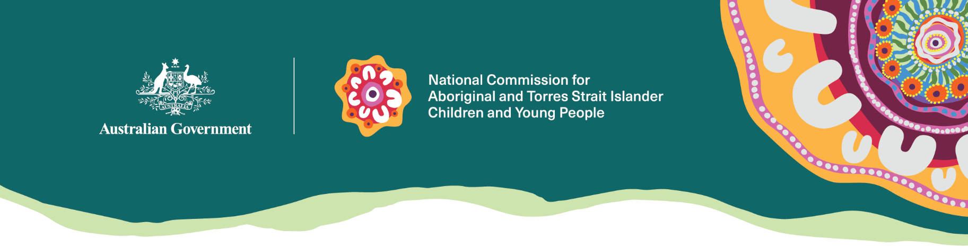
We focus on the safety and wellbeing of Aboriginal and Torres Strait Islander children and young people.
We are led by the National Commissioner for Aboriginal and Torres Strait Islander Children and Young people, Sue-Anne Hunter.

Why we are here
On matters affecting Aboriginal and Torres Strait Islander children and young people and their families, we:
- tell you about your human rights
- tell the government what you know to help them make good decisions for First Nations kids
- talk to you and other people working to help you so we all work together better
- speak up for you when we talk to the government.

How we do our work
Children and young people have rights, and Aboriginal and Torres Strait Islander people have rights under international law. We work in line with those rights, which Australia has agreed.
These rights include:
- saying what you think about matters that affect you
- taking your views seriously
- making sure people respect you and listen to you
- being safe
- being cared for in ways that respects your culture
- putting your best interests first
- respecting your identity
- being connected to family, community, culture and country.
We help children and young people to know about and use their rights.

What we do
We help make sure your voices are heard and your hopes and talents are used across Australia. We tell the government about ways things could be better and make sure everyone works together.

Who we answer to
We work to help improve the lives of Aboriginal and Torres Strait Islander children and young people. We are here for you and we report to the Minister for Social Services.

Contact us
enquiries@ncatsicyp.gov.au

