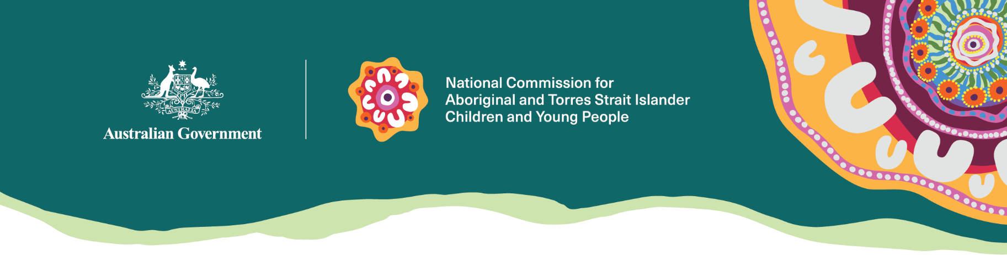
We are independent executive agency for Aboriginal and Torres Strait Islander children and young people focused on safety and wellbeing.

Our people
We are led by the National Commissioner for Aboriginal and Torres Strait Islander Children and Young people, Sue-Anne Hunter.

Our work
On matters affecting Aboriginal and Torres Strait Islander children and young people and their families, we:
- promote and protect human rights through strategic policy advice and reports to government
- provide advice to Government on and inform implementation of key policy frameworks to improve outcomes
- consult with Aboriginal and Torres Strait Islander children and young people and their families, and across Commonwealth and state and territory governments, commissioners, guardians and advocates and non-government organisations to promote and enhance coordination
- ensure the voices of Aboriginal and Torres Strait Islander children and young people are reflected in advice to government.

Our approach
The National Commission for Aboriginal and Torres Strait Islander Children and Young People was created to protect and promote the rights, interests and wellbeing of Aboriginal and Torres Strait Islander children and young people. We do this by:
- listening to them and amplifying their voices
- making sure systems treat them fairly and that governments keep their promises
- helping everyone work together to change things that aren't working.
We know that children and young people are experts in their own lives. They know what they need to grow up feeling safe, happy and strong in their culture. That’s why we get better results when we listen to what they think.
At the National Commission, we recognise children and young people as emerging leaders and changemakers. Every day, we see them caring for their communities and speaking out against injustices. But kids also deserve to play and dream. They need the freedom to explore and make mistakes. When the world feels heavy on their shoulders, our job as adults is to put it back at their feet.

Rights, interests and wellbeing
The National Commission focuses on the rights, interests and wellbeing of Aboriginal and Torres Strait Islander children and young people. Rights are rules that make sure everyone has the things they need to be safe, healthy and happy. Aboriginal and Torres Strait Islander children and young people have the right to (among many things):
- be safe, healthy and go to school
- be part of their community and connected to their culture
- be listened to and taken seriously in decisions about their life.
Rights tell us that kids have to be treated fairly and in their best interests. That means we have to make decisions that are good for kids, not just what’s easiest for adults.
The wellbeing of children and young people is supported when we make sure their rights and interests come first. Having wellbeing means you feel safe, happy, and connected to who you are.

Our activities
The rights of Aboriginal and Torres Strait Islander children and young people form the basis of the National Commission’s work. We approach our key activities in line with these rights and international processes and mechanisms. Australia has ratified and endorsed the United Nations Convention on the Rights of the Child and the United Nations Declaration on the Rights of Indigenous Peoples.
The rights set out in these international instruments include children’s right to:
- express their views in all matters affecting them
- have their views taken seriously
- not be discriminated against
- be safe from violence and harm
- receive culturally appropriate care
- have their best interests prioritised and their identity respected
- be connected to family, community, culture and country.
As part of the National Commission’s purpose to protect and promote the rights of Aboriginal and Torres Strait Islander children and young people, we support children and young people to understand and engage with their rights. Our approaches are informed by evidence (data, research and lived experience) and cultural ways of being (inclusive, diverse and culturally embraced).

Key activities
The National Commission’s key activities, outlined in our Corporate Plan, are to:
- amplify the voices, aspirations and strengths of Aboriginal and Torres Strait Islander children and young people
- provide advice to government
- enhance national coordination on matters related to Aboriginal and Torres Strait Islander children and young people.
This includes:
- developing engagement and collaboration with children and young people through a youth engagement model, and responding to enquiries with sensitivity and efficiency to make sure people are directed where they need to go
- advising on the policy and legislation underpinning the establishment of the National Commission, as well as on policy, legislation and systems that affect Aboriginal and Torres Strait Islander children and young people and their families, by engaging with those affected and focusing on areas of greatest change potential
- increasing national coordination on matters related to Aboriginal and Torres Strait Islander children and young people, across states and territories and with Aboriginal community-controlled organisations, Elders, peak bodies and youth leaders.
The National Commissioner prioritises opportunities to
- centre children and young people and promote their rights, safety and wellbeing
- raise public awareness experiences and issues faced by Aboriginal and Torres Strait Islander children in out-of-home care and detention
- advocate protective approaches to youth justice concerns
- consult and engage with children and young people, particularly those in youth justice settings.

Our accountabilities
We are accountable to the public through the Australian Parliament and the Minister for Social Services.

Contact us
enquiries@ncatsicyp.gov.au

